**Q1 Solution:**

**A-1)**

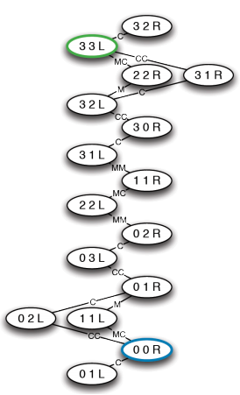

**A-2)** BFS, DFS since the search space is very small. Yes, since it is a requirement in this application.

**B)** Yes, it will provide an optimal result because it refers to the concept of admissibility where the estimated cost should be less than the actual cost.

**C)** IDS will perform much worse than DFS in the scenario where the goal node lies very near depth wise to the root node while there are a lot of branches on the tree. In this case, the algorithm will keep checking the branches before it could reach the goal state.

Q2:

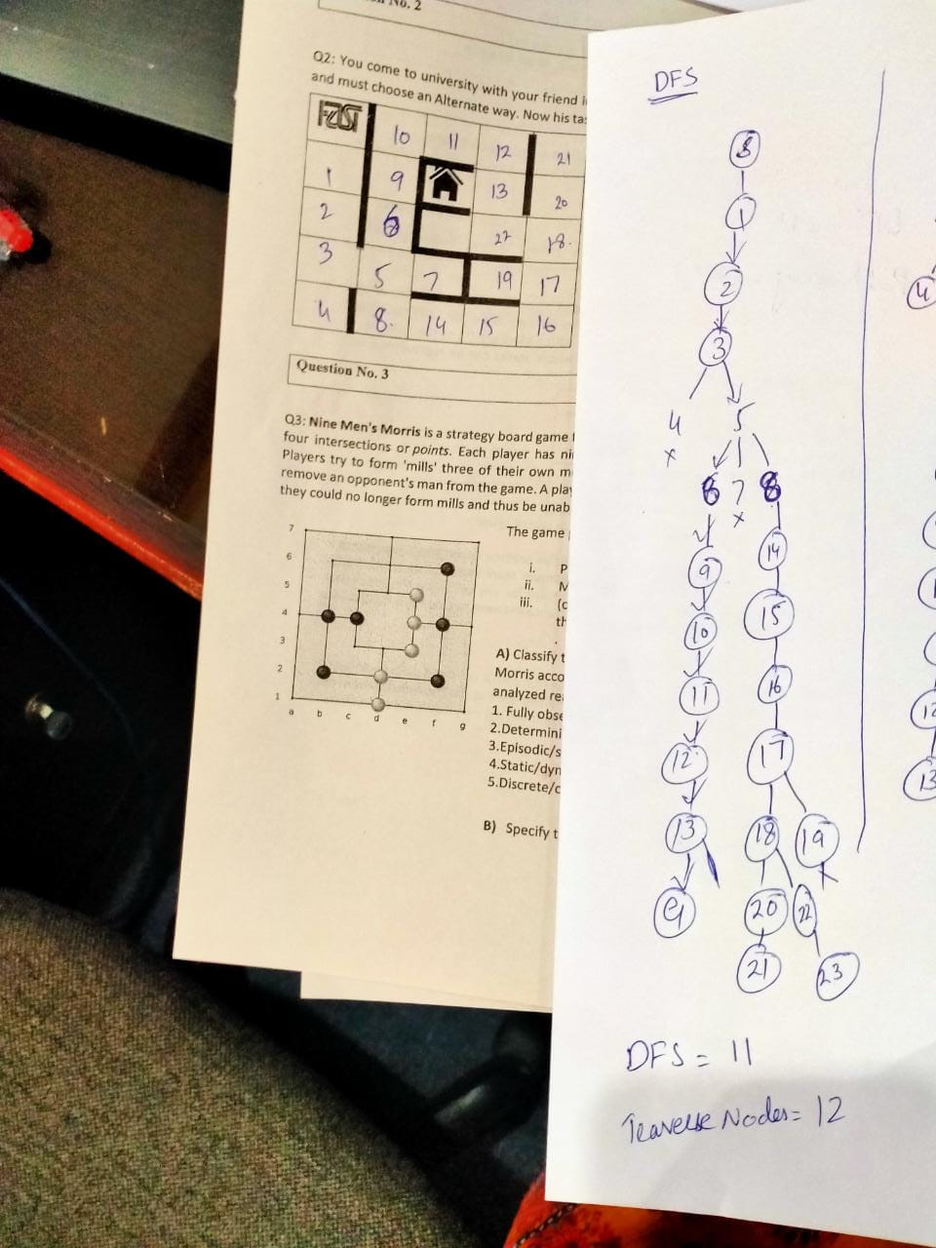

**Q3)**